**There are 4 print screens/code copy each worth 25%**

1. Complete the following program below using a JFrame & JCheckBox objects

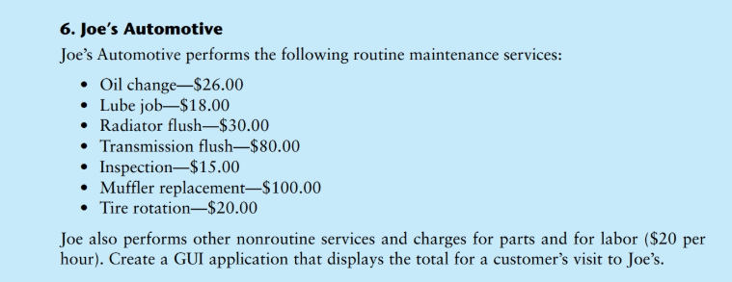

**#1 Choose all the routine maintenance services and total the amount with 2 hours of Labor charges and print screen below here**

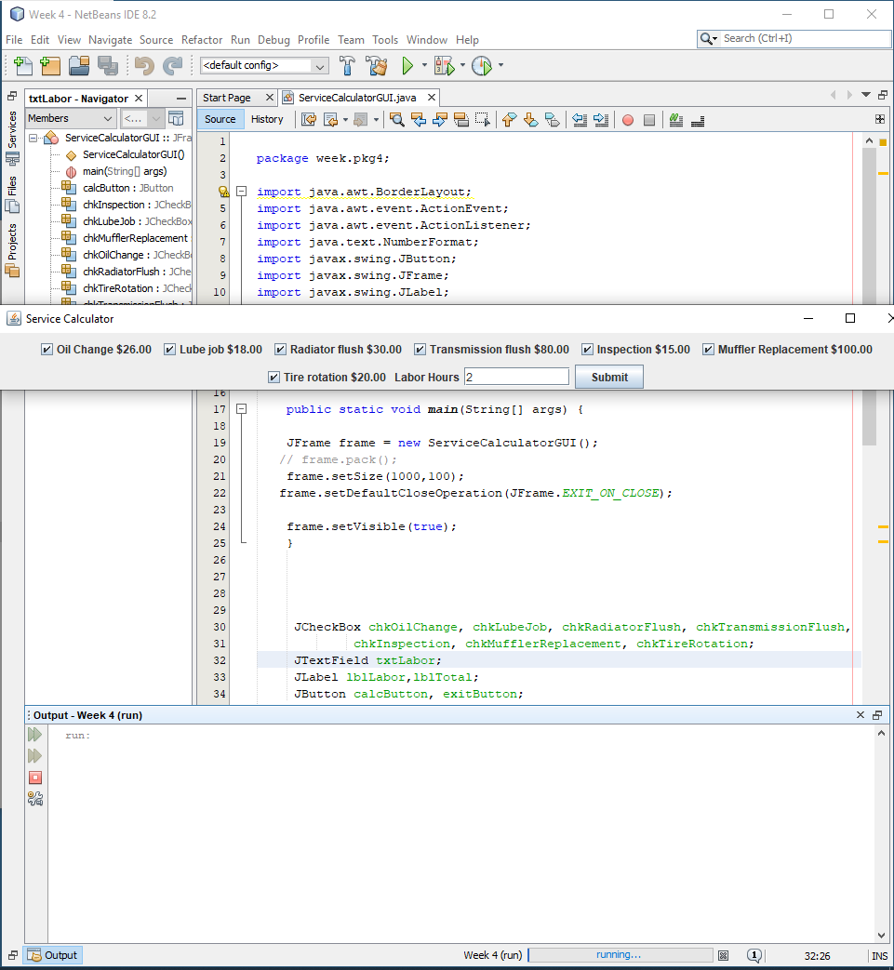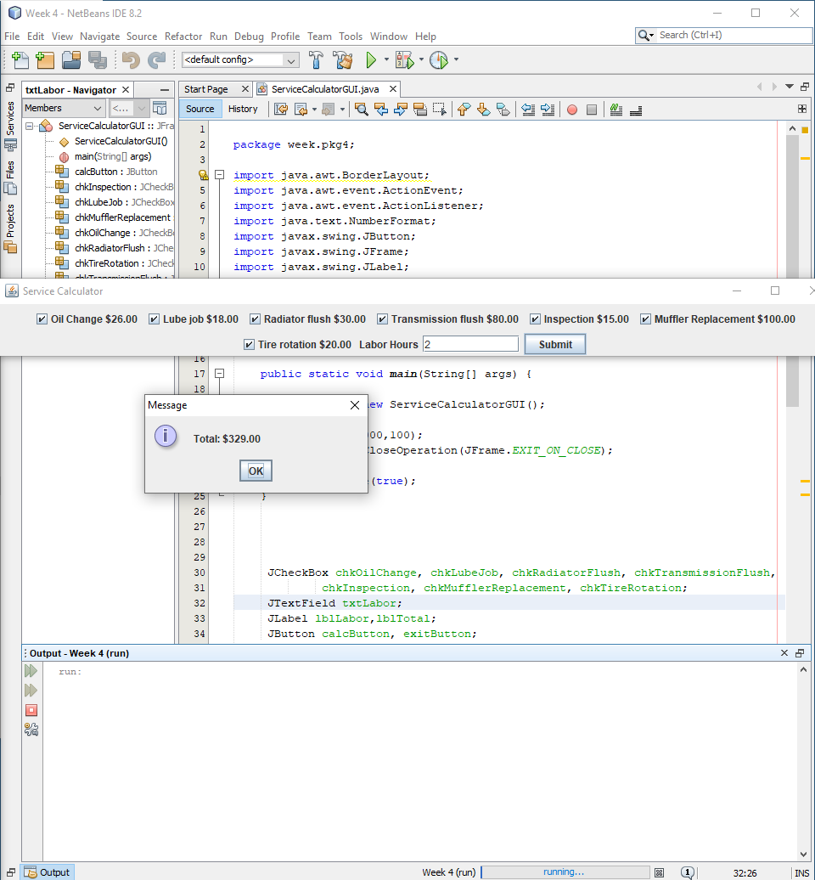

**#2 copy and paste the code below here**

package week.pkg4;

import java.awt.BorderLayout;

import java.awt.event.ActionEvent;

import java.awt.event.ActionListener;

import java.text.NumberFormat;

import javax.swing.JButton;

import javax.swing.JFrame;

import javax.swing.JLabel;

import javax.swing.JOptionPane;

import javax.swing.*;

public class ServiceCalculatorGUI extends JFrame {

public static void main(String[] args) {

JFrame frame = new ServiceCalculatorGUI();

// frame.pack();

frame.setSize(1000,100);

frame.setDefaultCloseOperation(JFrame.EXIT_ON_CLOSE);

frame.setVisible(true);

}

JCheckBox chkOilChange, chkLubeJob, chkRadiatorFlush, chkTransmissionFlush,

chkInspection, chkMufflerReplacement, chkTireRotation;

JTextField txtLabor;

JLabel lblLabor,lblTotal;

JButton calcButton, exitButton;

public ServiceCalculatorGUI()

{

setTitle("Service Calculator");

JPanel p= new JPanel();

p.add( chkOilChange = new JCheckBox ("Oil Change $26.00"));

p.add( chkLubeJob = new JCheckBox ("Lube job $18.00"));

p.add( chkRadiatorFlush = new JCheckBox ("Radiator flush $30.00"));

p.add( chkTransmissionFlush = new JCheckBox ("Transmission flush $80.00"));

p.add( chkInspection = new JCheckBox ("Inspection $15.00"));

p.add( chkMufflerReplacement = new JCheckBox ("Muffler Replacement $100.00"));

p.add( chkTireRotation = new JCheckBox ("Tire rotation $20.00"));

p.add(lblLabor = new JLabel("Labor Hours"));

p.add(txtLabor = new JTextField(10));

p.add(calcButton = new JButton("Submit"));

p.add(lblTotal = new JLabel ());

add(p);

calcButton.addActionListener(new ActionListener()

{

public void actionPerformed (ActionEvent e)

{

double total=0.0;

double labor = Double.parseDouble(txtLabor.getText());

double oilChange = 26.00;

double lubeJob = 18.00;

double radiatorFlush = 30.00;

double transmissionFlush = 80.00;

double inspection = 15.00;

double mufflerReplacement = 100.00;

double tireRotation = 20.00;

if(chkOilChange.isSelected()){total += oilChange;}

else {}

if(chkLubeJob.isSelected()){total += lubeJob;}

else {}

if(chkRadiatorFlush.isSelected()){total += radiatorFlush;}

else {}

if(chkTransmissionFlush.isSelected()){total += transmissionFlush;}

else {}

if(chkInspection.isSelected()){total += inspection;}

else {}

if(chkMufflerReplacement.isSelected()){total += mufflerReplacement;}

else {}

if(chkTireRotation.isSelected()){total += tireRotation;}

else {}

labor *= 20;

total += labor;

NumberFormat currency = NumberFormat.getCurrencyInstance();

JOptionPane.showMessageDialog(null,"Total: " + currency.format(total));

}

});

}

}

1. Complete the following program below using a JFrame

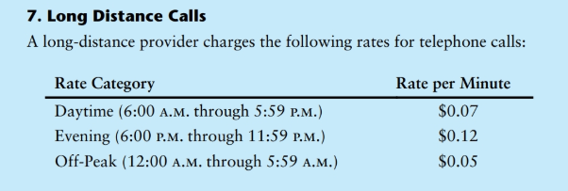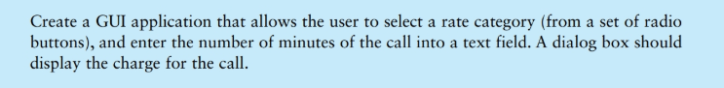

**#3 choose the Rate Category of Daytime and 60 minutes for the call and print screen below here**

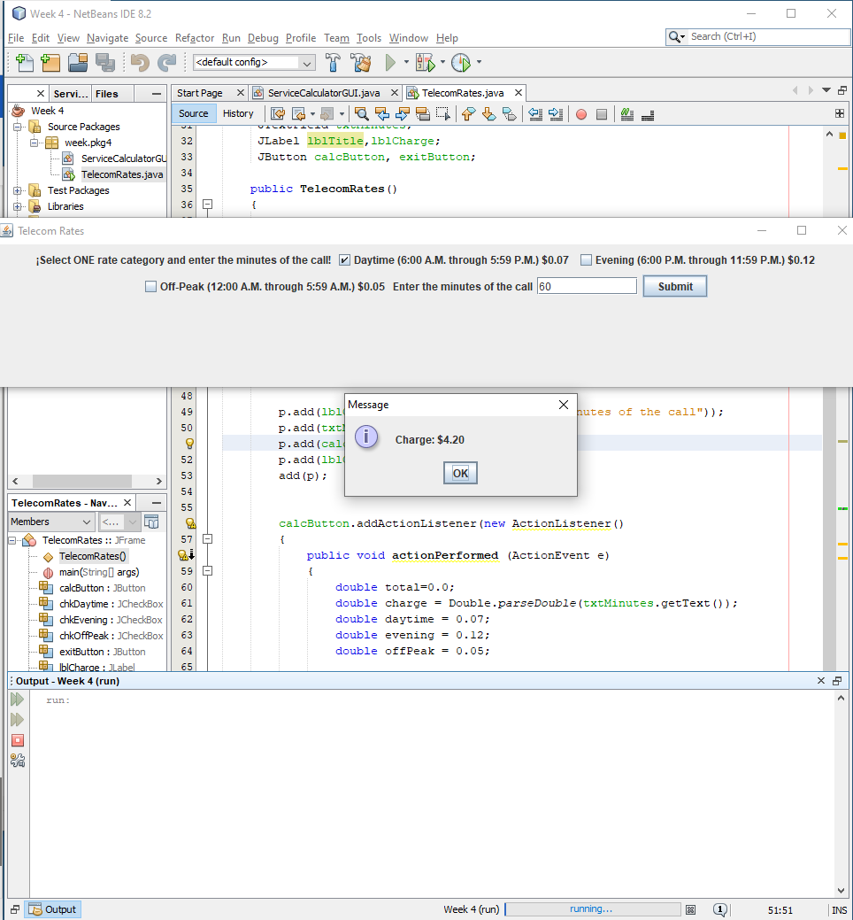

**#4 copy and paste the code below here**

package week.pkg4;

import java.awt.BorderLayout;

import java.awt.event.ActionEvent;

import java.awt.event.ActionListener;

import java.text.NumberFormat;

import javax.swing.JButton;

import javax.swing.JFrame;

import javax.swing.JLabel;

import javax.swing.JOptionPane;

import javax.swing.*;

public class TelecomRates extends JFrame {

public static void main(String[] args) {

JFrame frame = new TelecomRates();

// frame.pack();

frame.setSize(1000,200);

frame.setDefaultCloseOperation(JFrame.EXIT_ON_CLOSE);

frame.setVisible(true);

}

JCheckBox chkDaytime, chkEvening, chkOffPeak;

JTextField txtMinutes;

JLabel lblTitle,lblCharge;

JButton calcButton, exitButton;

public TelecomRates()

{

setTitle("Telecom Rates");

JPanel p= new JPanel();

p.add(lblTitle = new JLabel("¡Select ONE rate category and enter the minutes of the call!\n"));

p.add( chkDaytime = new JCheckBox ("Daytime (6:00 A.M. through 5:59 P.M.) $0.07"));

p.add( chkEvening = new JCheckBox ("Evening (6:00 P.M. through 11:59 P.M.) $0.12"));

p.add( chkOffPeak = new JCheckBox ("Off-Peak (12:00 A.M. through 5:59 A.M.) $0.05"));

p.add(lblCharge = new JLabel("Enter the minutes of the call"));

p.add(txtMinutes = new JTextField(10));

p.add(calcButton = new JButton("Submit"));

p.add(lblCharge = new JLabel ());

add(p);

calcButton.addActionListener(new ActionListener()

{

public void actionPerformed (ActionEvent e)

{

double total=0.0;

double charge = Double.parseDouble(txtMinutes.getText());

double daytime = 0.07;

double evening = 0.12;

double offPeak = 0.05;

if(chkDaytime.isSelected()){total += daytime;}

else if (chkEvening.isSelected()){total += evening;}

else if (chkOffPeak.isSelected()){total += offPeak;}

else {total = 0;}

total *= charge;

NumberFormat currency = NumberFormat.getCurrencyInstance();

JOptionPane.showMessageDialog(null,"Charge: " + currency.format(total));

}

});

}

}

**Submit this document to Module 4 Homework**